Exhibitor Information Pack 2022

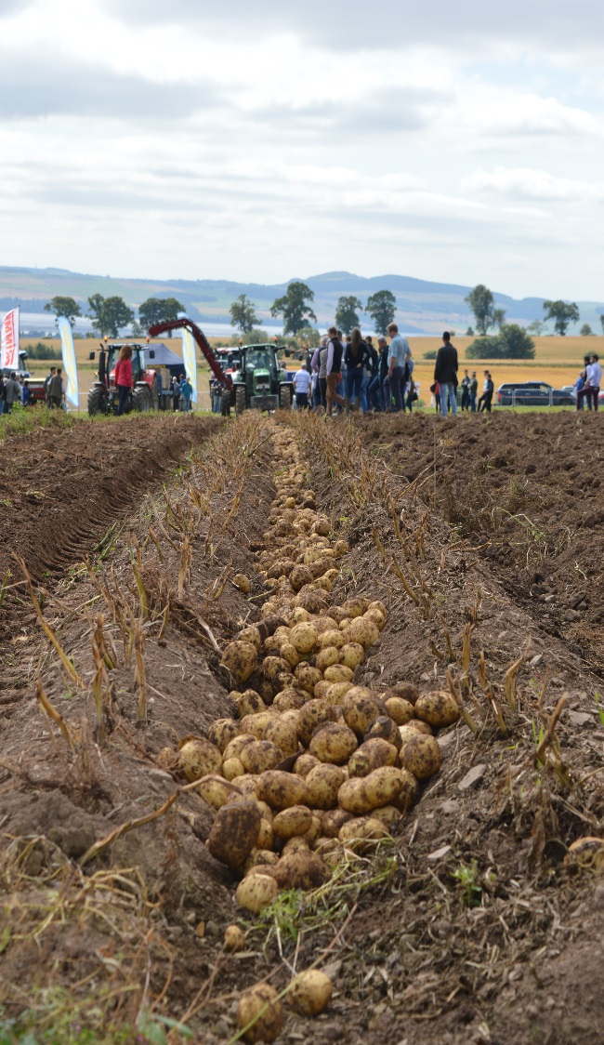
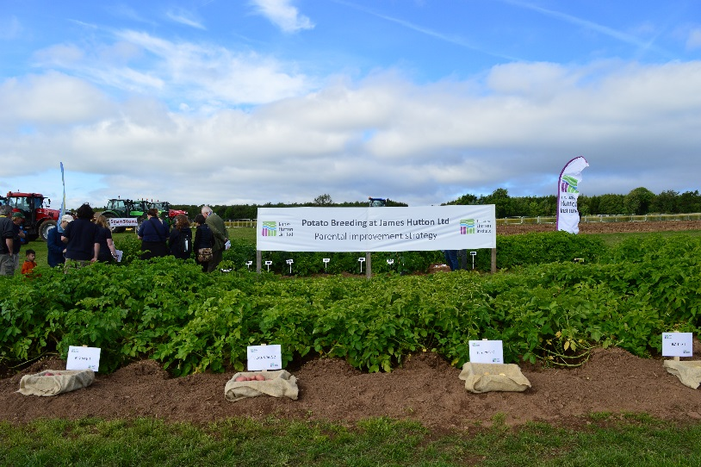

Information for Exhibitors

Organiser Details

Lucy Mitchell, Events Co-ordinator

Any enquiries regarding bookings including stand space, adverts etc. as well as set-up and break down arrangements.

Tel: 01382 568 850 Email: events@hutton.ac.uk

David Young, Field Manager

Any enquiries about site access and machinery bookings.

Tel: 01382 568 748 Email: david.young@hutton.ac.uk

Derek Coyle , Trials Officer
Any enquiries regarding field plot treatments and seed delivery.
Tel: 07886087489 Email: Derek.Coyle@huttonltd.com

Exhibitor Deadlines

Submit booking forms for field plots and moving machinery demos | 1 March 2022
Submit field plot treatment forms (one per plot) | 1 March 2022
Deliver seed for field plots | 7 March 2022
Submit booking forms for marquee and static machinery spaces | 15 April 2022
Submit risk assessment | 28 May 2022
Register staff working on your stand | 10 July 2022
**To ensure smooth event running late entries will not be accepted this year.**

Booking Terms and Conditions

Any exhibitor cancelling their booking for any reason other than Covid-19 restrictions before 24 June 2022 will only receive a 50% refund. After this date, no return of fees will be made. The organisers reserve the right to ‘re-sell’ your space.

General Information

Exhibitor bookings will be allocated on a first-come basis. Please note that exhibitor spaces are limited and all spaces may be allocated before the booking deadline. If you wish to guarantee a space, please send your completed booking form to us as soon as possible. This year late entries will not be accepted.

Companies are responsible for producing their own literature for visitors and are required
to have a representative present on the day, for the duration of the event.

The James Hutton Institute requires evidence of an organisation’s inspection and testing regimes for any portable electrical appliances or equipment they intend to use at this event. This should be submitted with the risk assessments prior to the event. Should you not have P.A.T certification available, you must provide documented evidence of how your organisation inspects your electrical equipment. If any electrical item is deemed unfit for purpose on the day of inspection by the Hutton health and safety team, you will not be able to use it at the event.

Please note, exhibitors will be invoiced after the event. Any additional chargeable costs incurred by exhibitors on the day, such as banners/flags not previously booked, will be invoiced post-event.

Health and Safety
All exhibitors must complete a Risk Assessment for each booking. This will be sent to you after you have placed your booking.

Build and Breakdown Arrangements

The site will be available for setting up from 10am to 6pm on Wednesday 10 August. Exhibitor vehicles will not be allowed to transport items from the car park to the field plots and Hutton staff will assist you with transportation of material from car park to field plot area if necessary. This change is for everyone’s safety on site and to protect the site from damage by vehicle movements.

All your plot and exhibit-related materials must be onsite and ready for display before 8am on event day.

PLEASE NOTE: For health and safety reasons, plot and exhibit-related materials must not be taken down or removed until after the event closes at 4.30pm.

The venue must be clear of all display items by 10am on Friday 12 August. Anything left on site will be removed to the farm steading for collection. No responsibility will be accepted for items left at the steading.

Access to the venue

There will be branded event signage to the venue from all approaches and online directions can be found at pip.hutton.ac.uk

It is essential that you follow the event signage and ignore your satnav or other instructions. We have carefully planned the best route to the event site to minimise traffic disruption through the village as well choosing the most accessible roads for heavy traffic and large vehicles.

Parking is in a grassed area of the field where the event is held. Car parking marshals will be on hand to guide you in and out of the car park.

Once the event is finished, again please follow the event signage until you reach the main road.

Please note: Heavy machinery will be held back until the car park is empty of other vehicles. This is to avoid any traffic jams and hold ups on the narrow country roads.
Exhibit Options

Exhibitor Outdoor Stands

Organisations wishing to exhibit are invited to bring and erect their own gazebos and show case their products outside, or indeed to exhibit outside without a structure. Please note for health and safety reasons gazebos must be industrial gazebos and fit for purpose. Standard open spaces for this, 3m x 3m are offered at £350 plus VAT. If you require more space please purchase in the booking process:

Cost per additional linear meter of frontage:
1m: £115 plus VAT
2m: £230 plus VAT

This price includes two food/drink vouchers, one 6’ x 2.5’ trestle table and two x folding chairs. Additional food and refreshments will be available to purchase during the event or you can bring your own.

A very limited number of outdoor electricity supplies are available and these can be booked for your stand for £50 plus VAT. One 13amp, single double socket electricity point will be provided. No additional sockets / extension leads will be permitted for use. You must adhere to all Electrical and Health & Safety requirements associated with the use of any electrical equipment you intend to use.
Hutton requires evidence of your organisation’s inspection and testing regimes for any portable electrical appliances or equipment you intend to use at this event. This must be submitted with the risk assessments prior to the event. Should you not have P.A.T certification available, you must provide documented evidence of how your organisation inspects your electrical equipment. If any electrical is not fit for purpose on the day of inspection by the Hutton Health and Safety Team, you will not be permitted to use it.

The Events Coordinator in conjunction with the health and safety team will monitor the weather forecast and should the wind speed increase to an unsafe limit, a decision will be taken to either reduce all temporary demountable fabric structures and/or equipment where practicable, or to close the event.

Field Demonstration Plots

If you would like to demonstrate your company product/varieties in a field plot, we offer a standard sized plot across 8 beds / 16 drills of c. 4m in length, with a c. 6m path for public access on the day.

This year there are two different plot types on offer and for the first year we are offering a new cover crop plot option along with the standard potato plot. This is for exhibitors who wish to show plots that are cover crop only and do not require the standard agronomic & disease control regimes as well as the harvest requirements that a potato plot does.

Please also note that exhibitors are no longer allowed to plant or harvest their own plots so as a result, plots will be planted and harvested by James Hutton Institute staff. We are offering full harvest or bulk harvest options for field plot exhibitors.

Bulk-harvested plot £950 + VAT
Plot contents will be bulk harvested and disposed of by James Hutton Institute staff.

Fully-harvested plot £1300 + VAT
Plot contents will be harvested, boxed, labelled, transported and stored for you.

Cover-crop plot £450 + VAT
This is for exhibitors who wish to show plots that are cover crop only and do not require the standard agronomic & disease control regimes as well as the harvest requirements that a potato plot does.

Should you identify extra requirements for your plot after you have submitted your booking and Field Treatment forms, please email your requirements to us as soon as possible – written instructions do not go astray, unlike verbal ones. Please email events@hutton.ac.uk. The James Hutton Institute will take no responsibility for discrepancies in requirements if instructions are not received in writing and acknowledged by James Hutton Institute staff. You will be invoiced separately for any additional requirements post-harvest.

Please submit your Booking and Field Treatment forms before 1 March 2022. Bookings received after this date WILL NOT be accepted.

Please note that seed must be sent to the James Hutton Institute for the attention of Derek Coyle by no later than 7 March 2022.

All seed used in field plots must be Scottish classified seed.

Field Plot Marquee (only available with a field plot bookings)

If you wish to erect a gazebo or similar beside your plot (maximum size 3m x 3m), this must be booked by 1 March 2022. An additional charge of £150 + VAT will be levied. Under no circumstances will marquees larger than 3m x 3m be permitted unless pre-approved. Gazebos must be industrial and fit for purpose. This is for health and safety reasons as the field plot site has been carefully laid out to allow sufficient room for visitors to walk a round the plots.

This price includes one 6’ x 2.5’ trestle table and two x folding chairs.

The Events Coordinator in conjunction with the health and safety team will monitor the weather forecast and should the wind speed increase to an unsafe limit, a decision will be taken to either reduce all temporary demountable fabric structures and or equipment where practicable, or to close the event.

Whistlestop Plot Tours

Organised tours of the plots provide a taster session for visitors who can then revisit plots they are interested in. Therefore, please prepare a 5 to 10 minute talk as an introduction to the advantages of your varieties or treatments and ensure you keep to this time limit. Visitors are free to return to plots for further discussions throughout the day, so please make sure that your staff are available and easily recognisable (nname badges or identifiable clothing, please).

Outside Spaces (Static machinery and other displays)

Should your company wish an outdoor display area for static machinery or similar, or tattie boxes etc. the fee will be £325 + VAT per unit space.

All machinery must be pre-authorised by the James Hutton Institute prior to the event and will be charged per unit, in multiples of 4m frontage and defined depth, as ordered.

The location of your exhibit will be provided prior to the event. Any machinery not pre authorised may be refused admittance or will attract a surcharge.

If you wish to book outside space, please submit your online booking form before 15 April 2022.

Working Machinery Demonstrations

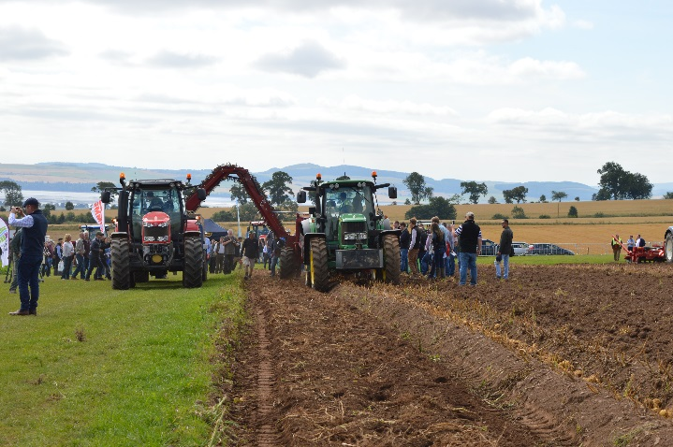
If your company would like to demonstrate their potato-related machinery, please contact David Young, Field Manager, in the first instance where you can discuss your requirements and the demonstration you would like to show. A final cost will be agreed, at which point you should complete the booking form and submit by 1 March 2022.

It is anticipated that you will provide a running commentary on the day during each demonstration so please prepare something appropriate.

Additional Advertising

Banners and Flags

Banners may be erected free of charge within a booked field plot or outside exhibit space. Additional banners can be erected on the 1m high crowd control barriers around the site at a charge of £50 + VAT per 3m length. Alternatively, you can display single feather flags around the site at a cost of £30 + VAT per flag or multiple feather flags at a cost of £75 + VAT. Space will be allocated on a strictly first come basis. Any banners or flags erected on event day without prior booking will be charged post-event.

Other Information
Refreshments and Lunch
There will be a number of refreshment stands around the site.

Health and Safety On-Site
There are a number of fully trained First Aiders on site during the event. Any working Machinery Demonstrations are carefully monitored through the day and precautions taken to assure the safety of all visitors.

Security
There will be security on-site from 7pm Wednesday 10 August to 7.30am Thursday 11 August.

Tips and advice for a successful exhibition

To ensure you get the most out of your exhibit, we would encourage you to:

- Use social media prior to and during the event, using #PotatoesInPractice. This hashtag, while not the shortest, is unique to the event.

- Make your exhibit as eye-catching as possible. There’s a limit to what you can do in a sloping field, we know that, but clever use of banners and display materials will make you stand out for the right reasons.

COVID – 19

Due to presence of Covid in society, further guidance will be given out to exhibitors nearer the time of the event.

